**MyLinkedin Database**

**ERD**

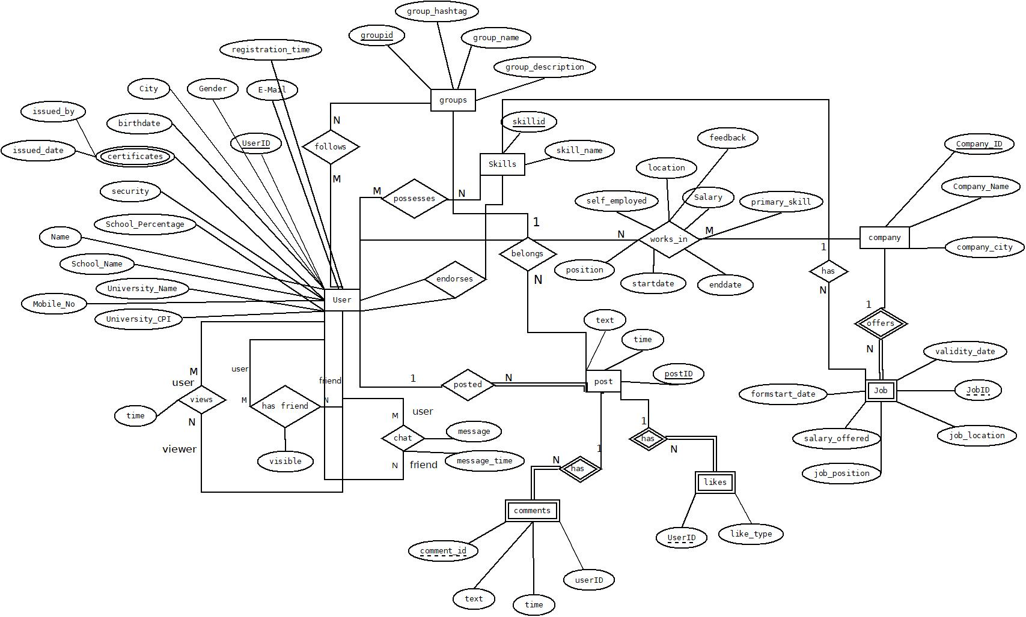

**Relational Schema**

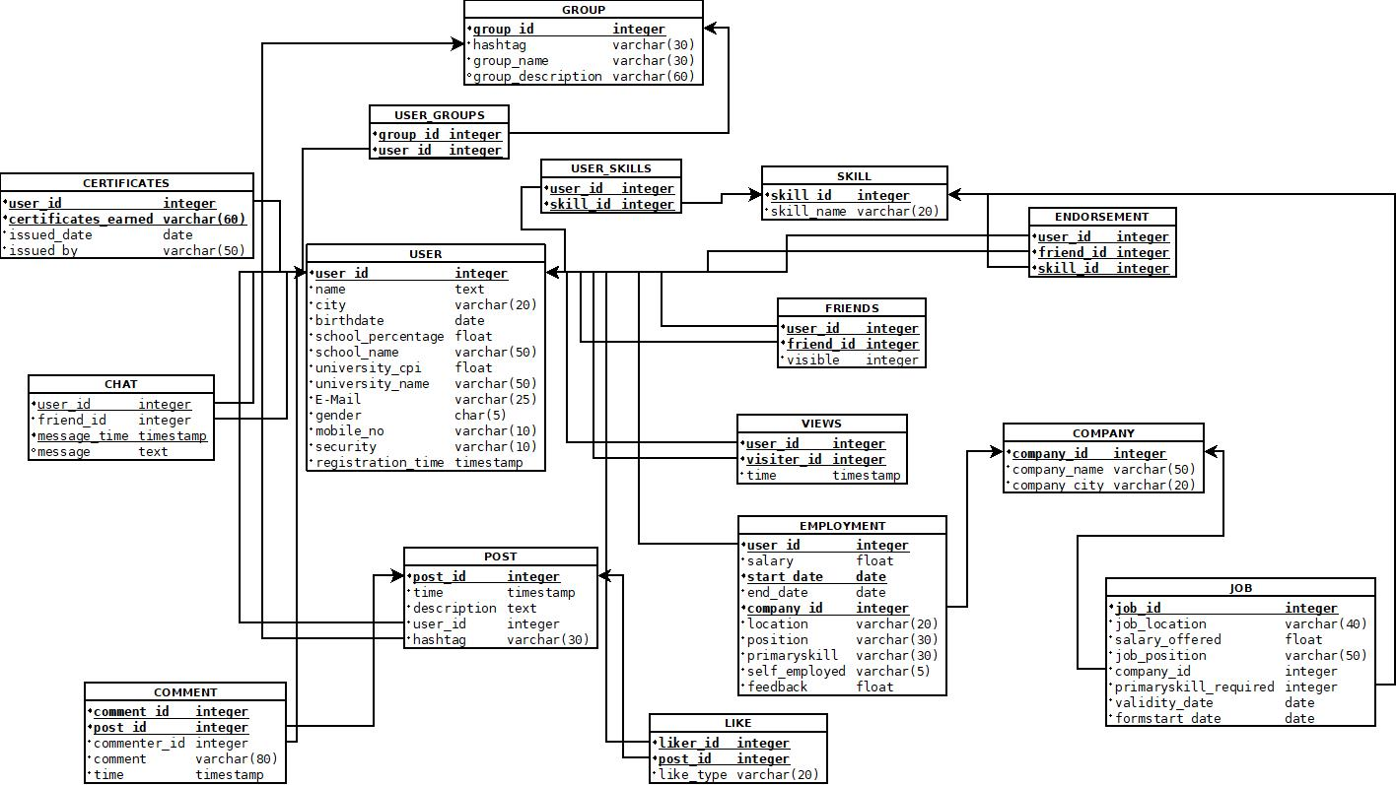

**Functional Dependencies**

**USER**

1. user_id → name

2. user_id → city

3. user_id → email

4. user_id → birthdate

5. user_id → gender

6. user_id → school_name

7. user_id → school_percentage

8. user_id → university_name

9. user_id → university_cpi

10. user_id → mobileno

11. user_id → security

12. user_id → registration_time

**SKILL**

1. skill_id → skill_name

**GROUP**

1. group_id→ group_name

2. group_id→ group_description

3. group_id→ group_hashtag

**POST**

1. post_id → text

2. post_id → time

3. post_id → hashtag_topic

**COMMENT**

1. post_id & comment_id → commenter_id

2. post_id & comment_id → comment

3. post_id & comment_id → time

**COMPANY**

1. company_id → company_name

2. company_id → company_city

**JOB**

1. job_id → job_location

2. job_id → salary_offered

3. job_id → position

4. job_id → primaryskill_required

5. job_id → company_id

6. job_id → validity_date

7. job_id → formstart_date

**FRIENDS**

1. user_id & friend_id → visible

**LIKE**

1. liker_id & post_id → like_type

**VIEWS**

1. user_id & visiter_id → time

**EMPLOYMENT**

1. user_id & startdate & company_id → salary

2. user_id & startdate & company_id → enddate

3. user_id & startdate & company_id → location

4. user_id & startdate & company_id → position

5. user_id & startdate & company_id → self_employed

6. user_id & startdate & company_id → primaryskill

7. user_id & startdate & company_id → feedback

**CERTIFICATE**

1. user_id & certificate_earned → issued_date

2. user_id & certificate_earned → issued_by

**CHAT**

1. user_id & message_time → friend_id

2. user_id & message_time → message

**Normalization Proof**

All FDs are minimal and dependent on the corresponding primary key of table so all tables are in BCNF